Syed Huzaifa Ali
CN Lab 04
23K-0004
BAI-6A

Task 01:
Roll No: 23K-0004, so 00.04.YY.0 is the format that should be used but 0.4.YY.X cannot be assigned so I used 1.4.YY.0
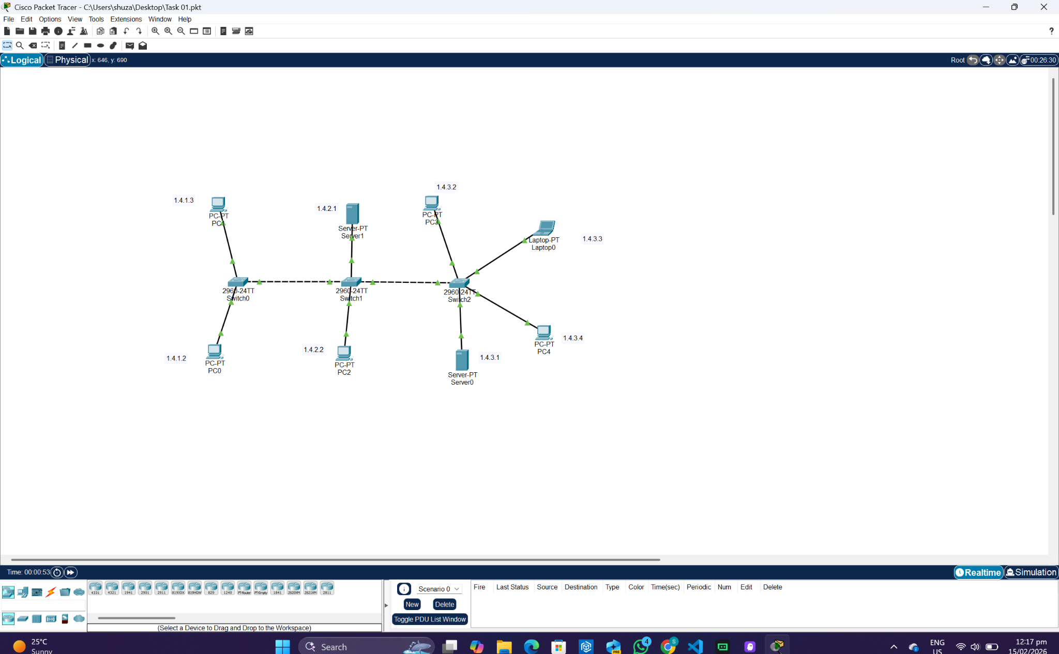

Pinging from PC 2
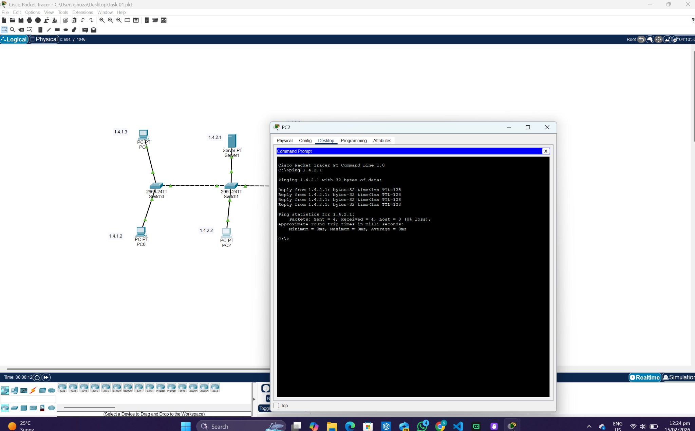
Pinging from PC 4
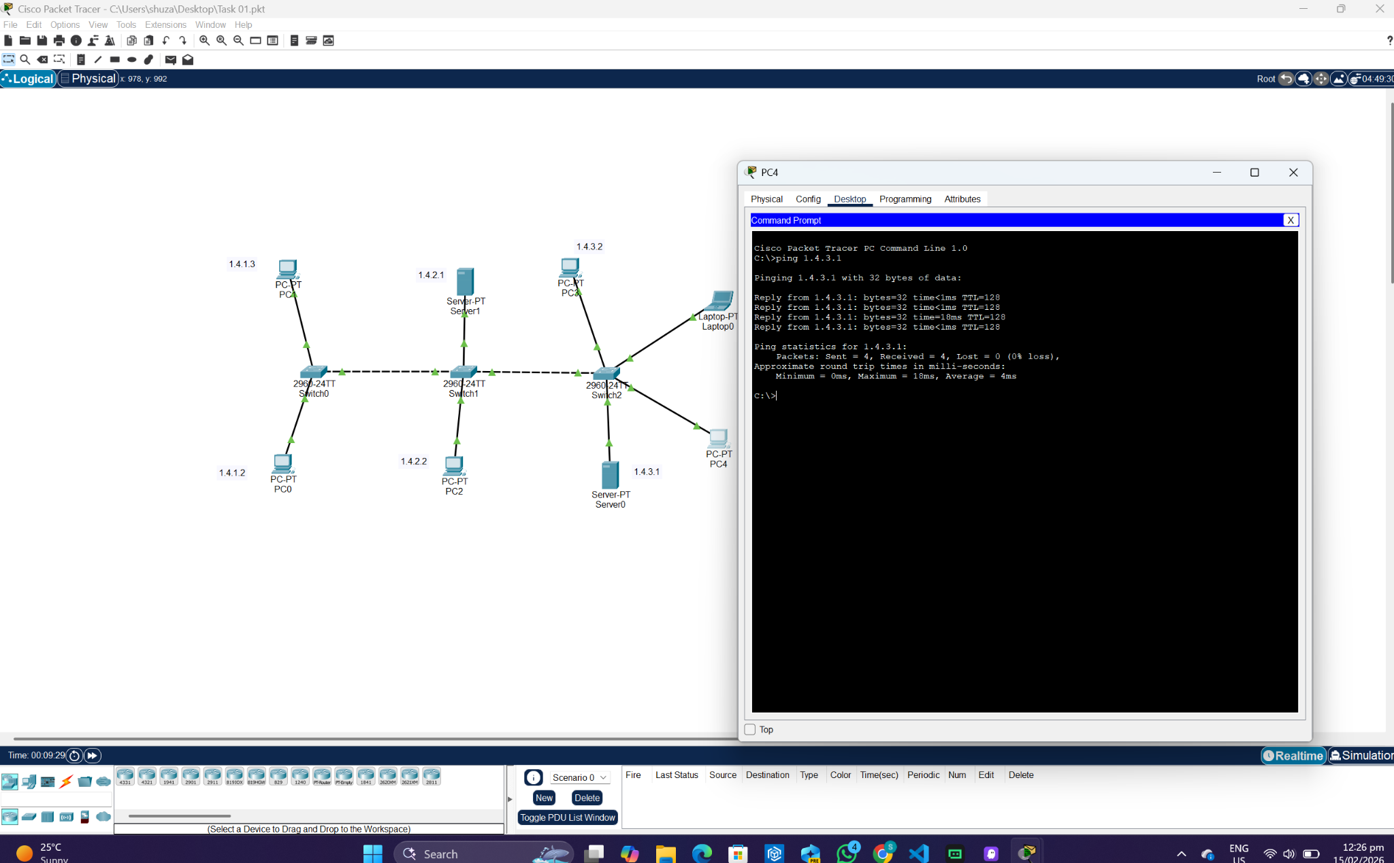
Telnet Verification:
Switch 0 CLI:
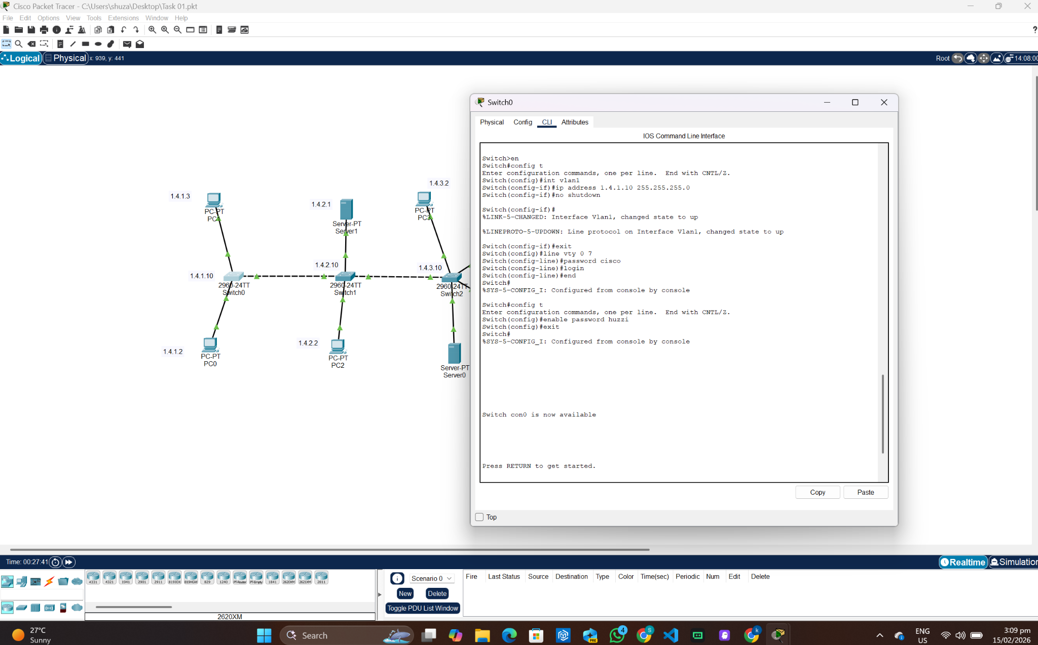
Switch 1 CLI:
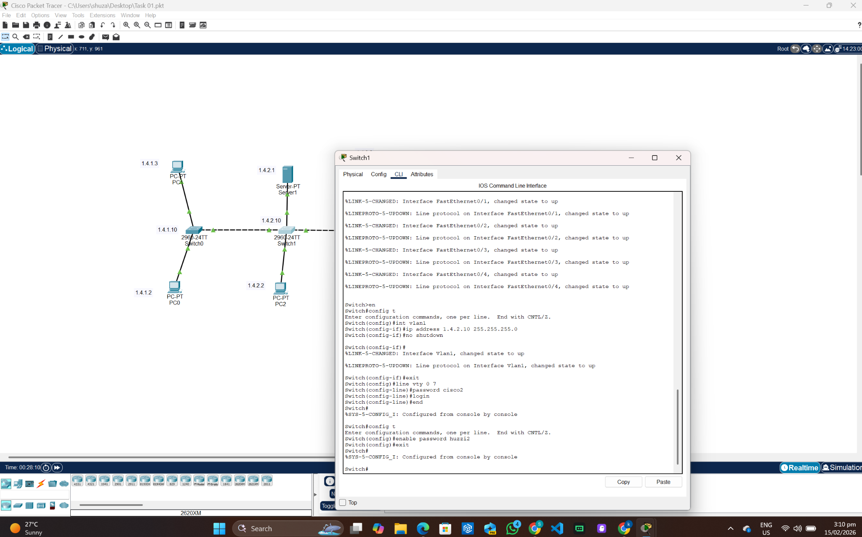
Switch 2 CLI:
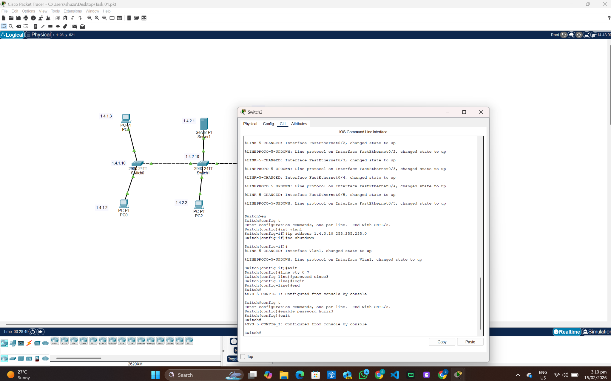

PC 0:
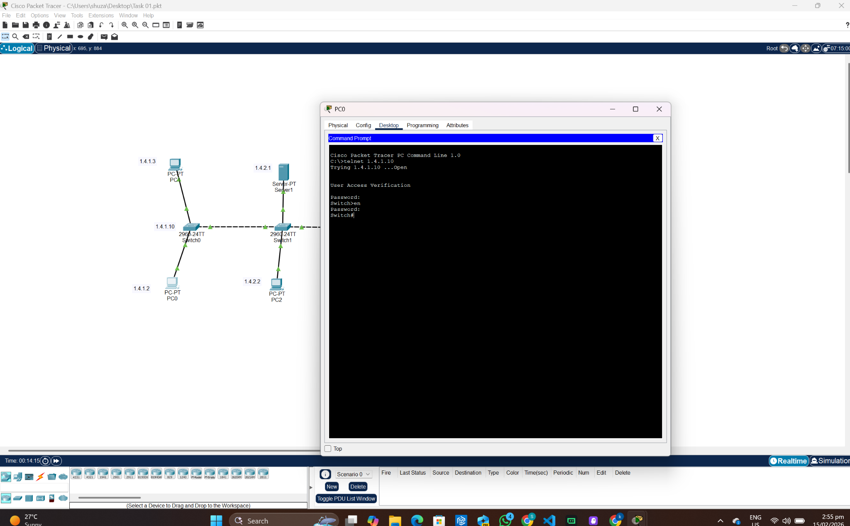

PC 1:
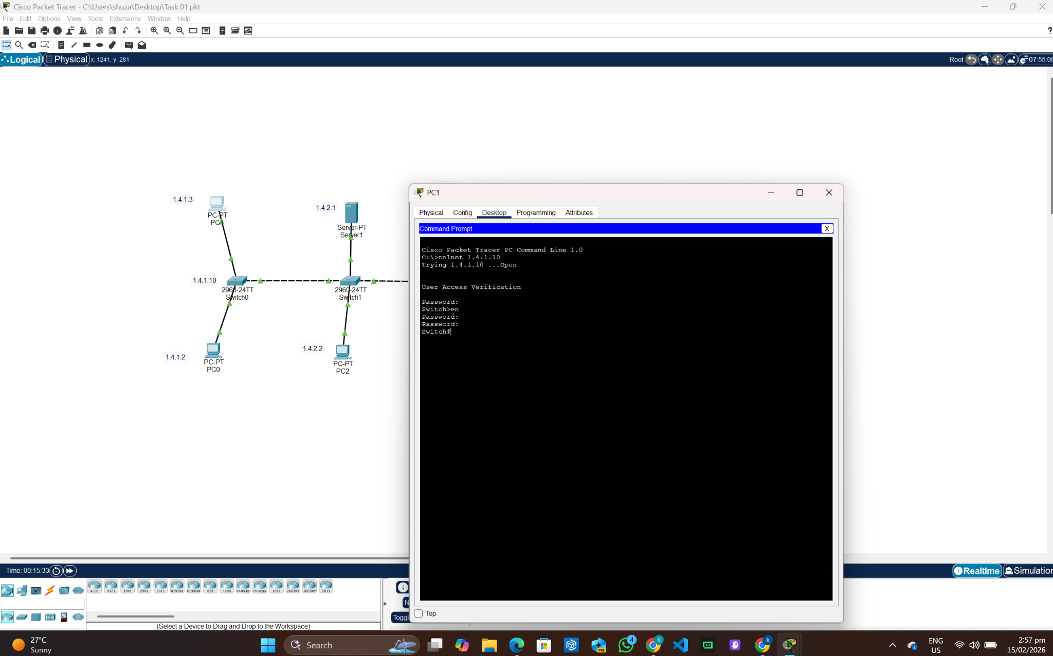
PC 2:
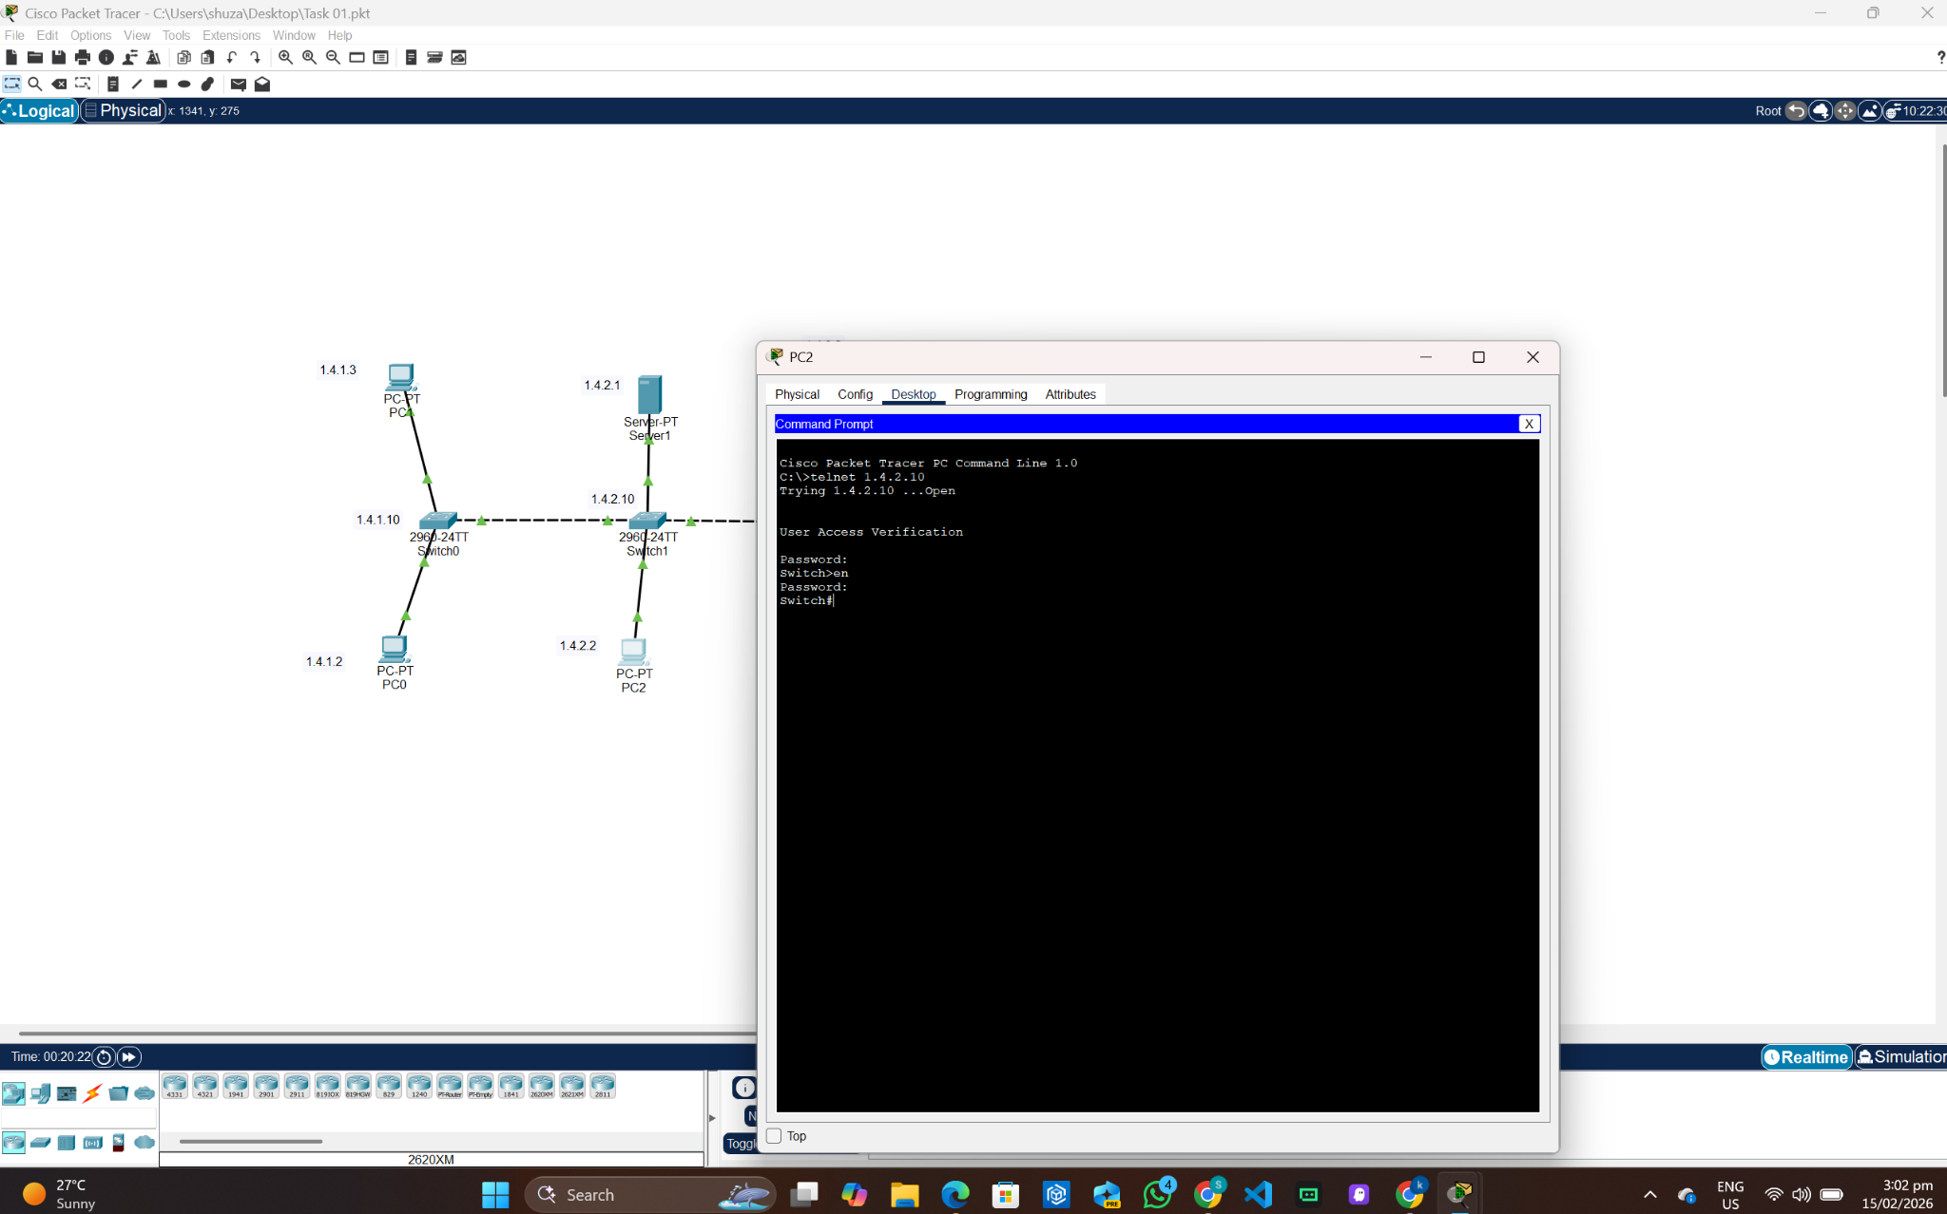
PC 3:
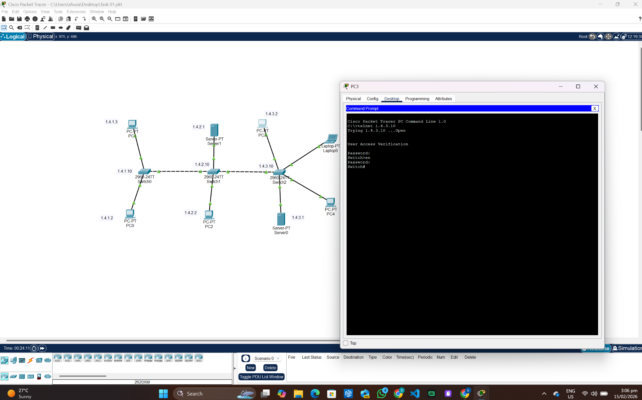
PC 4:
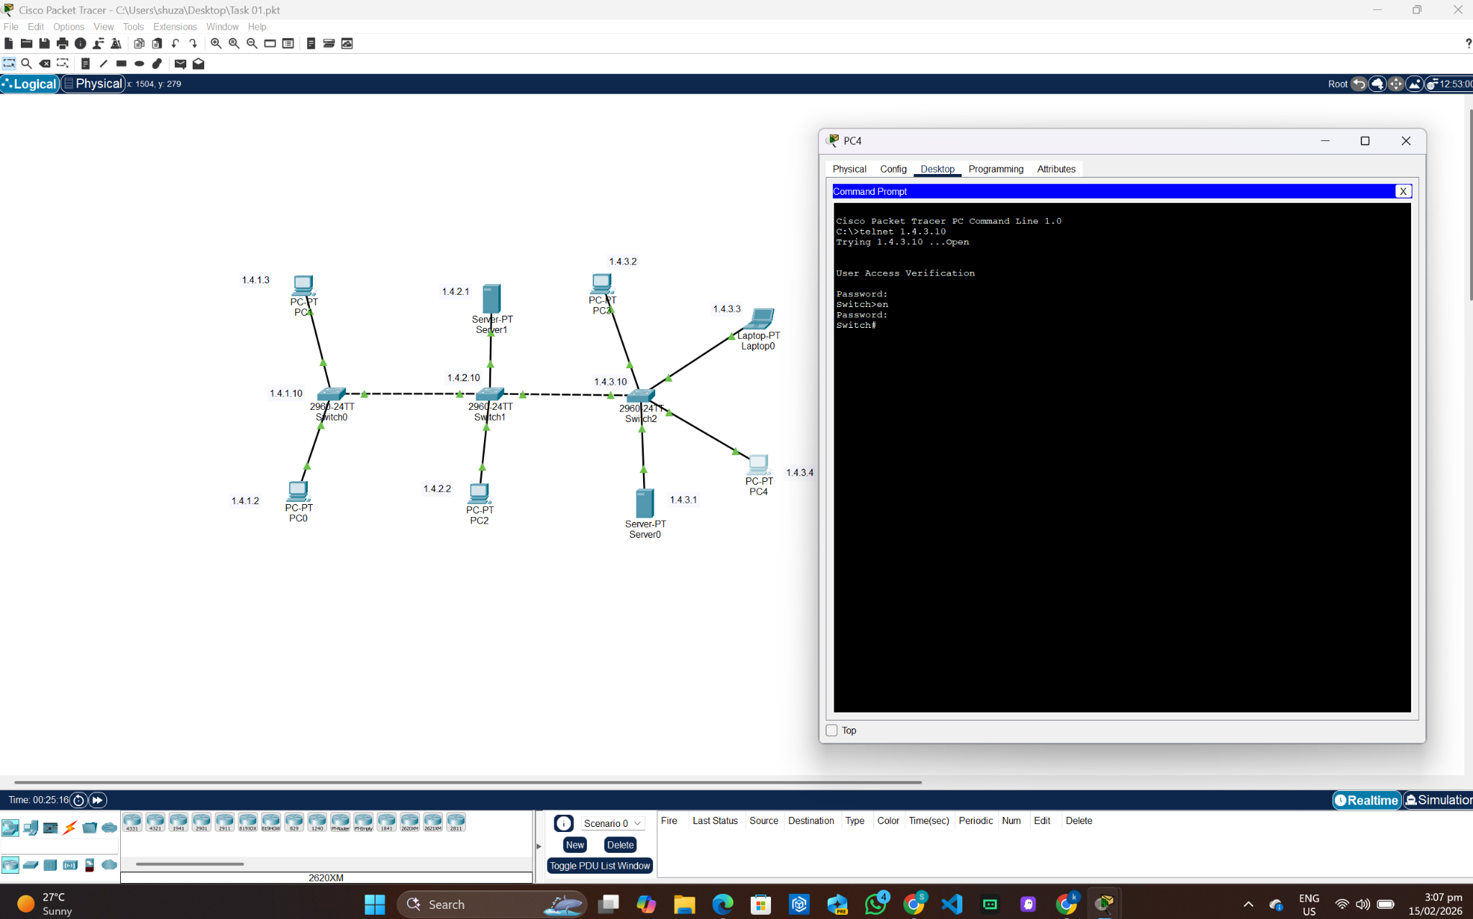
Laptop 0:
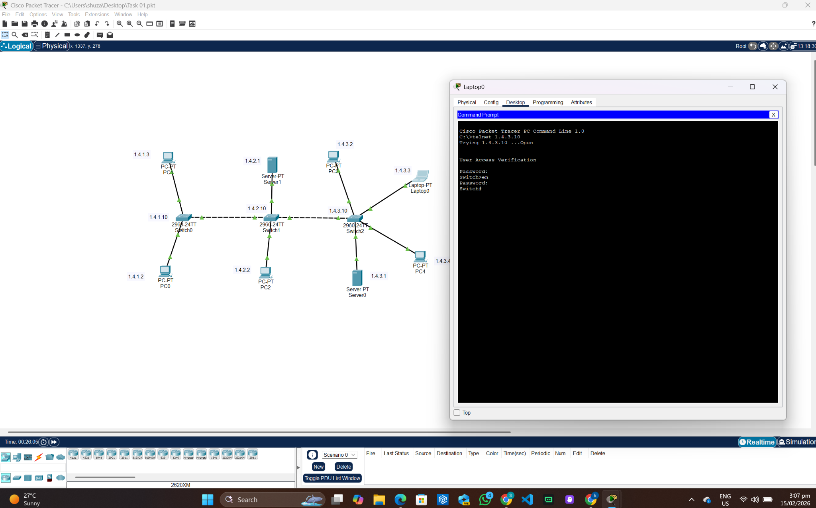
Changing the IP of Switch 2 (Switch 1) using PC 2:
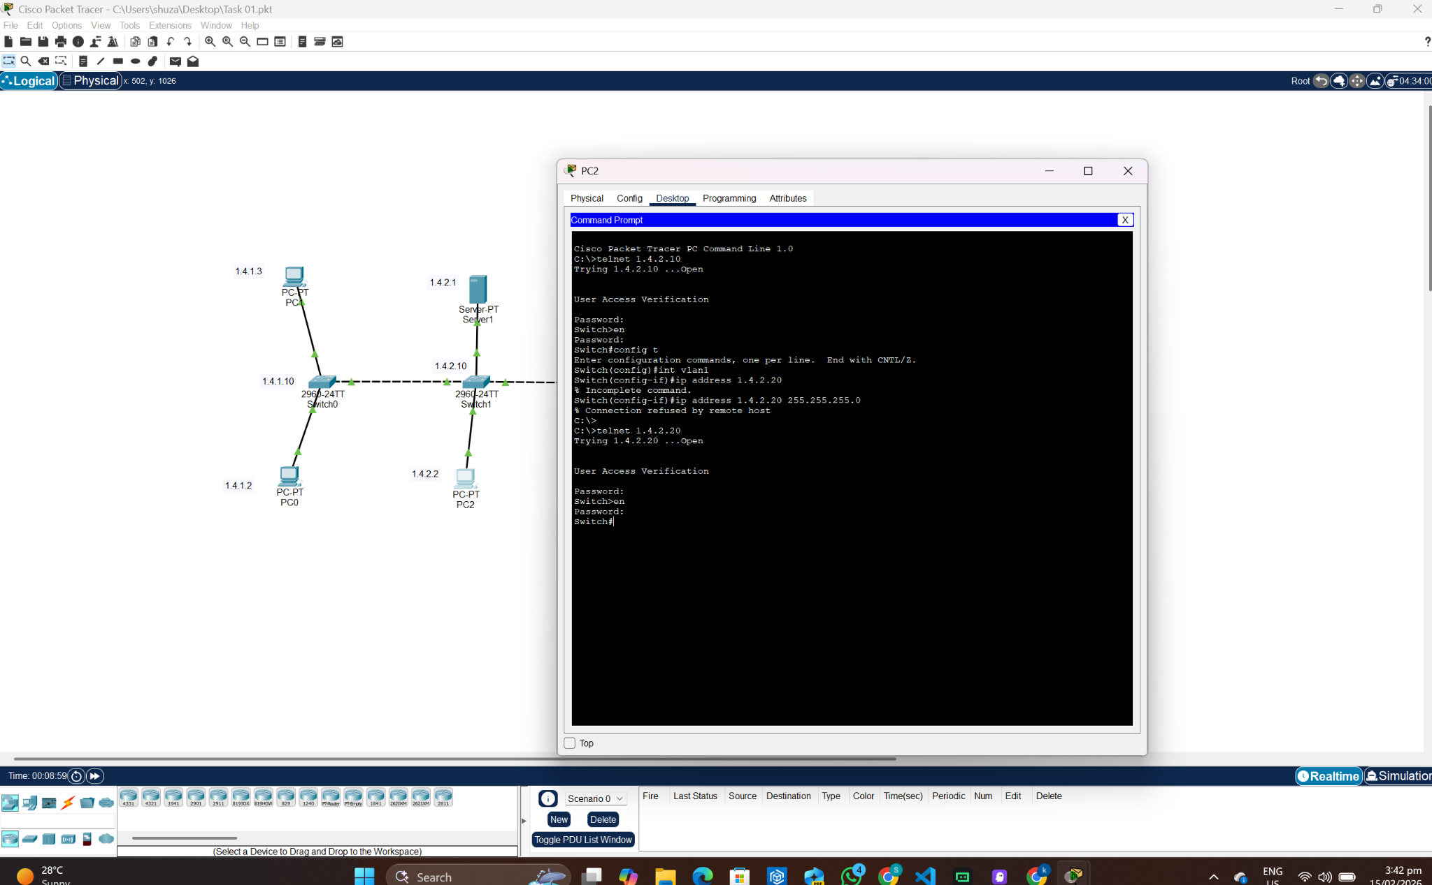
Task 02:
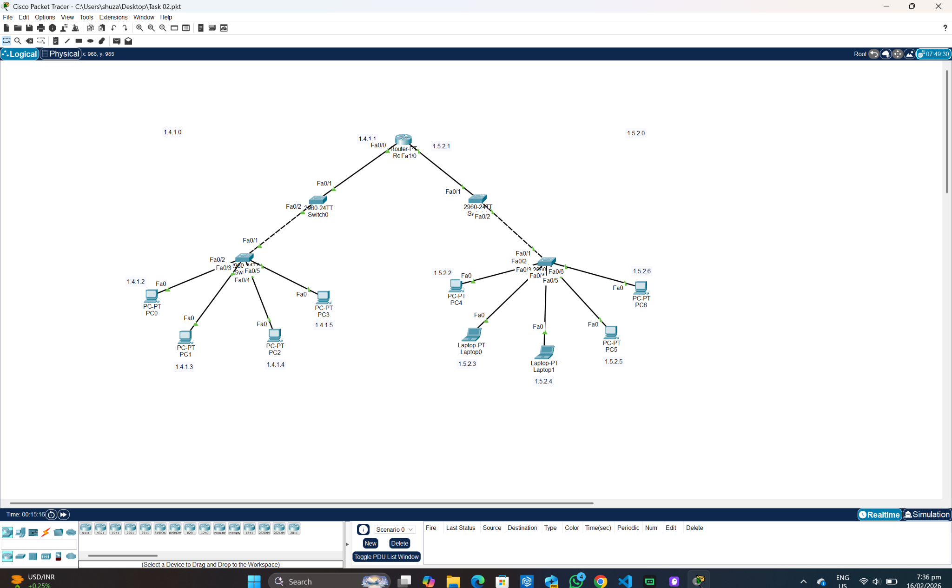
Pinging from PC 2:
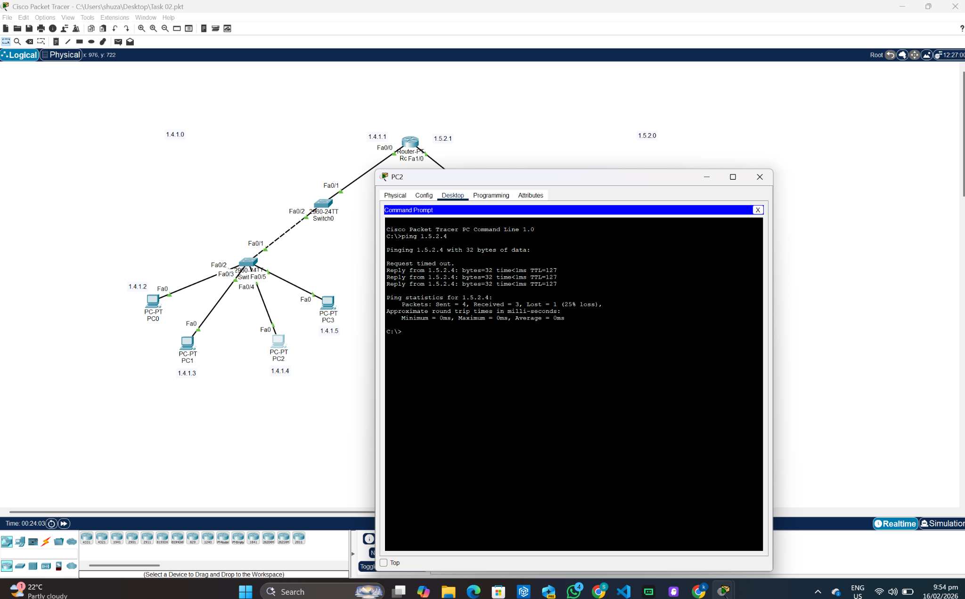
Pinging from Laptop 1:
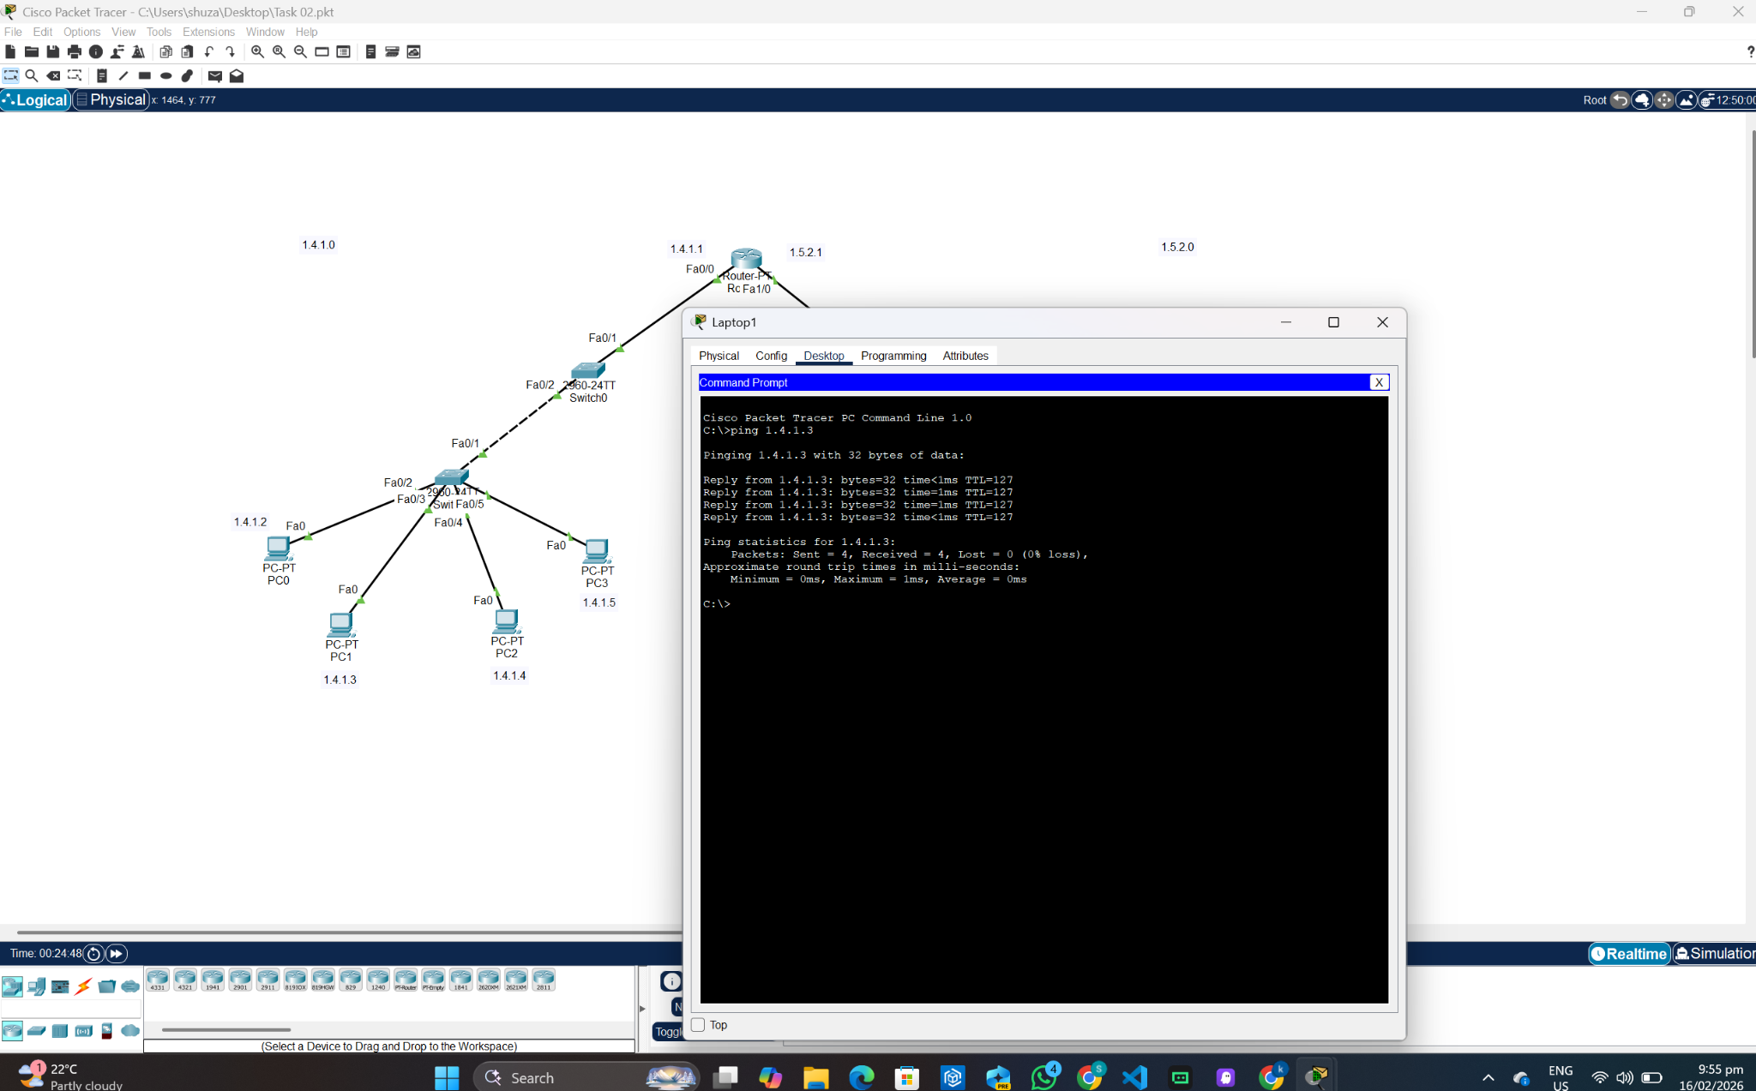

Telnet Verification:
PC 1:
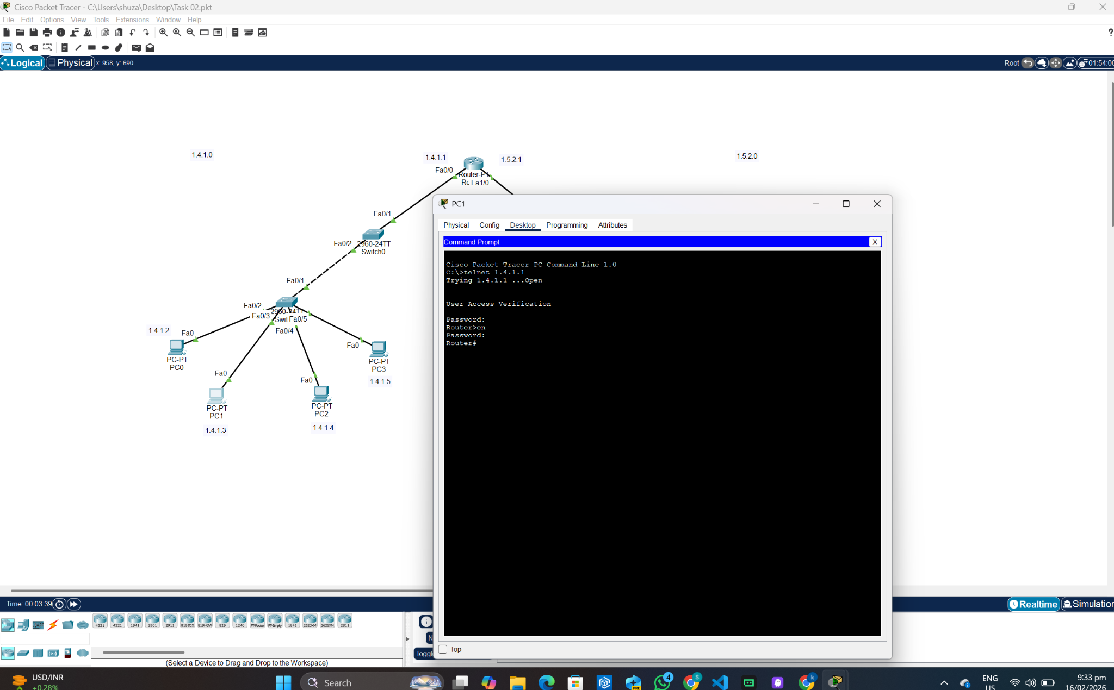
Laptop 0:
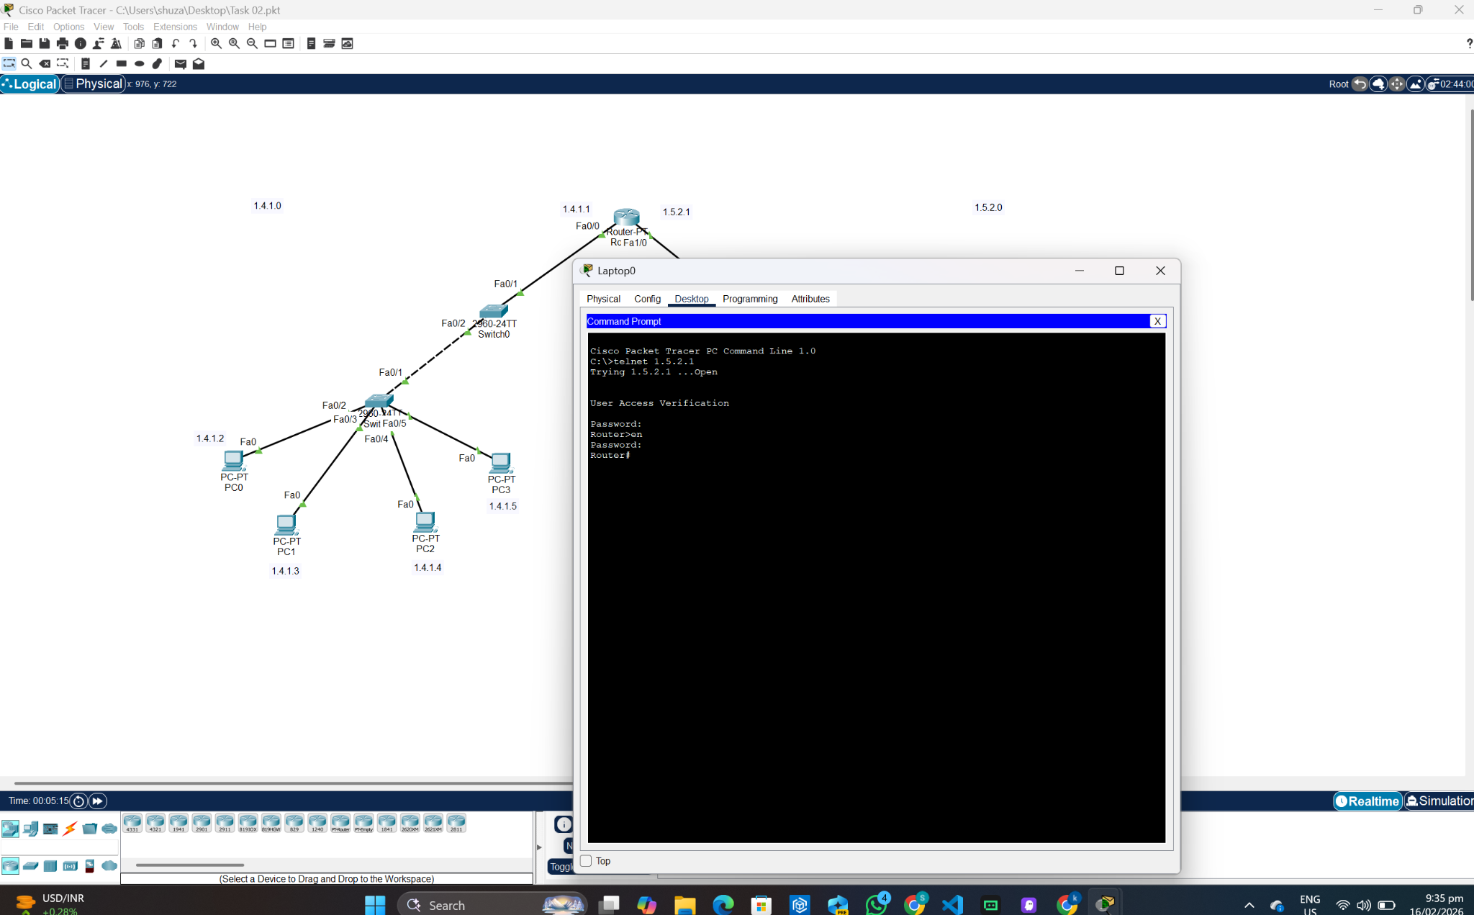
SSH:
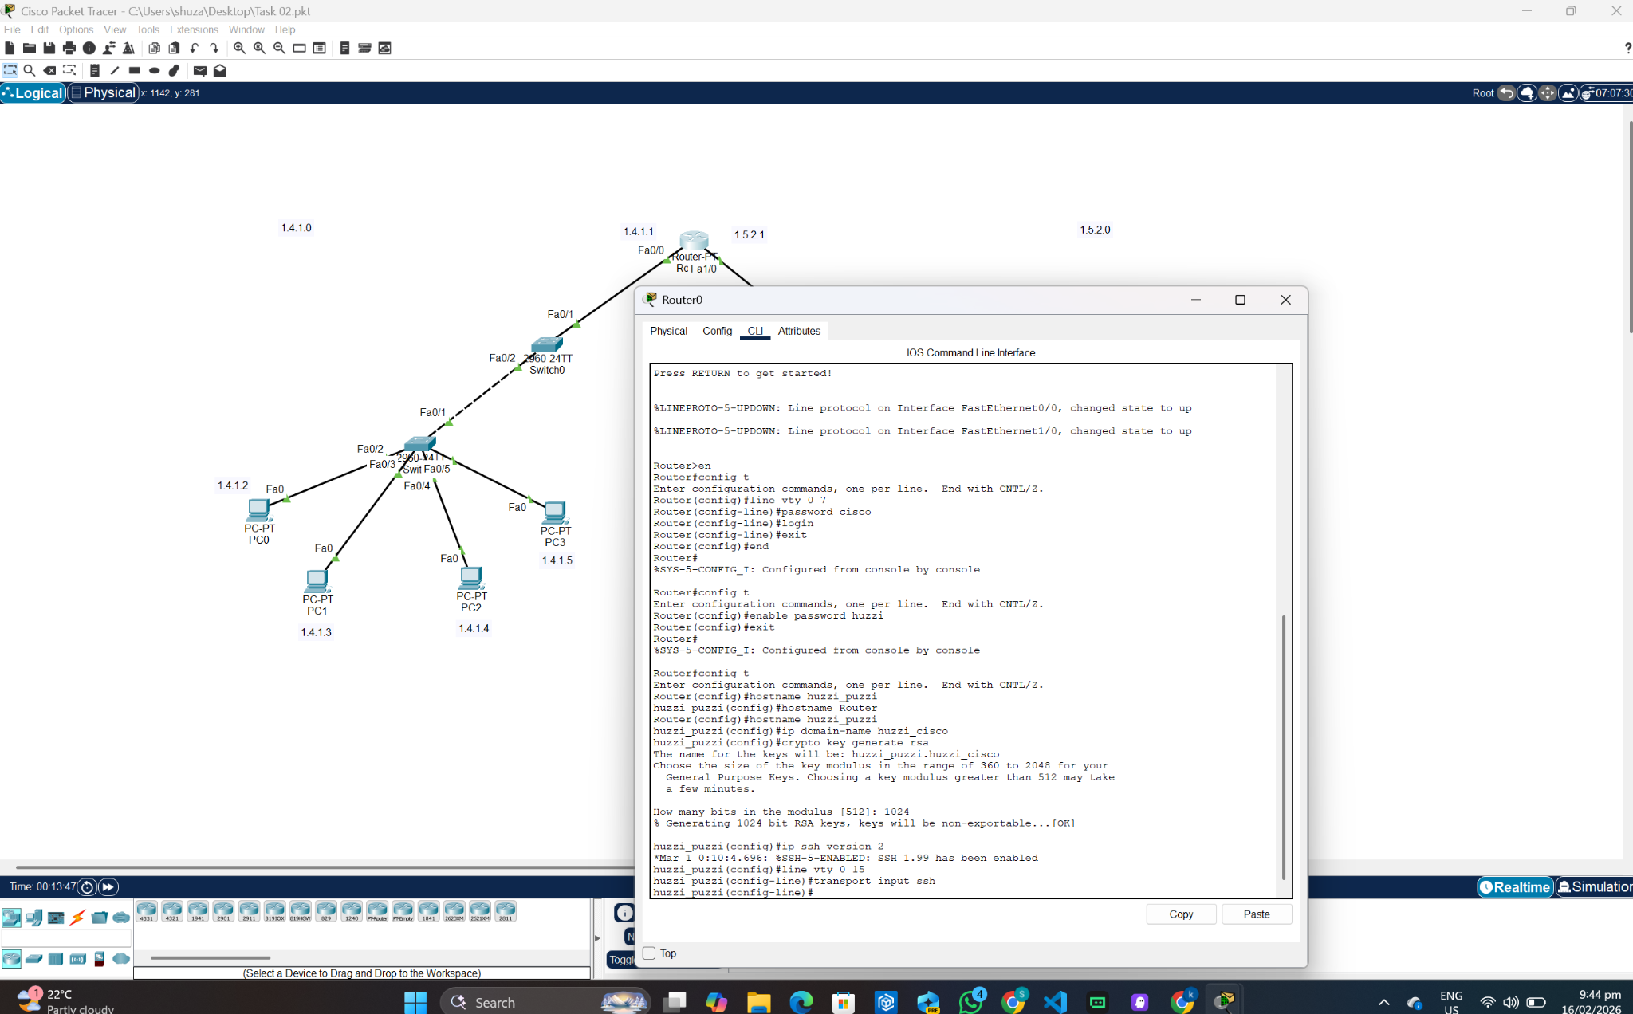
SSH Verification using Laptop 0 and IP assignment:
